API Documentation

#### **URL Shortening**

* POST /api/shorten

Request Body:

{

"longUrl":"https://github.com/google/guava/wiki/InternetDomainNameExplained#public-suffixes-and-private-domains",

"customAlias":"github",

"topic":"code"

}

Headers

Key value

Authorization Bearer Testing

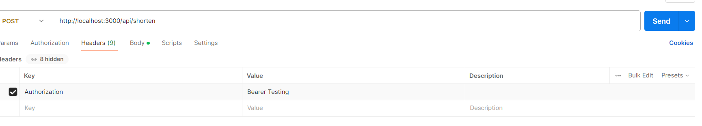

Response: { "shortUrl": "http://localhost:3000/api/github",

"createdAt": "2024-12-05T19:49:11.146Z"

}

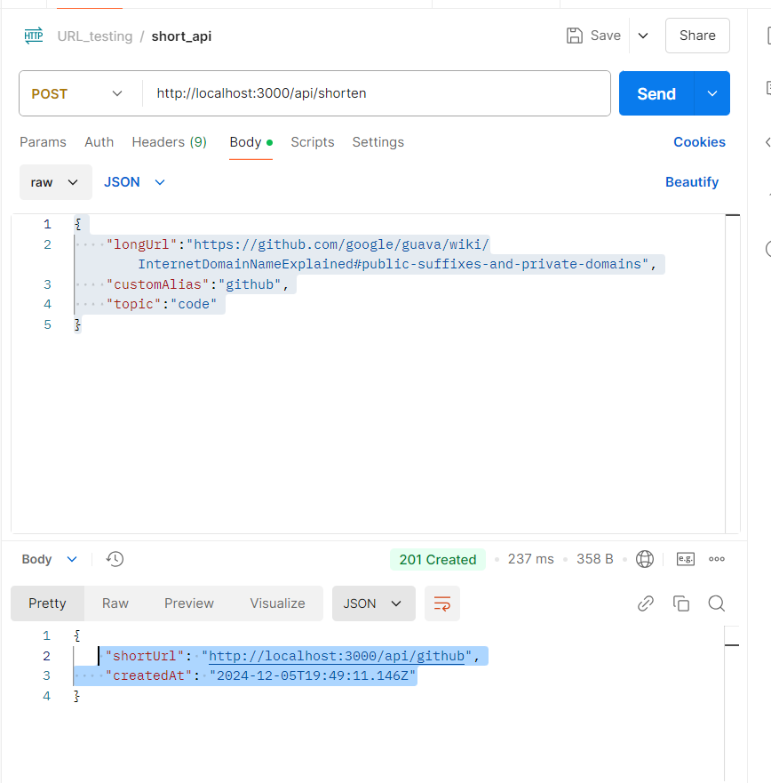

* GET /:alias

Redirects to the original URL.

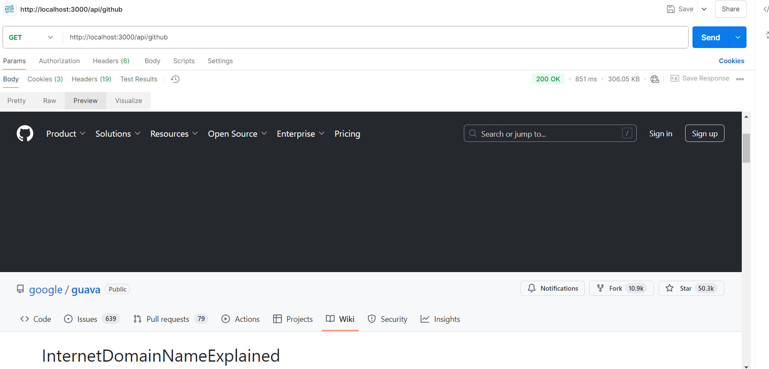

#### 

#### 

#### **Analytics**

* GET /api/analytics/overall

Fetch overall analytics.

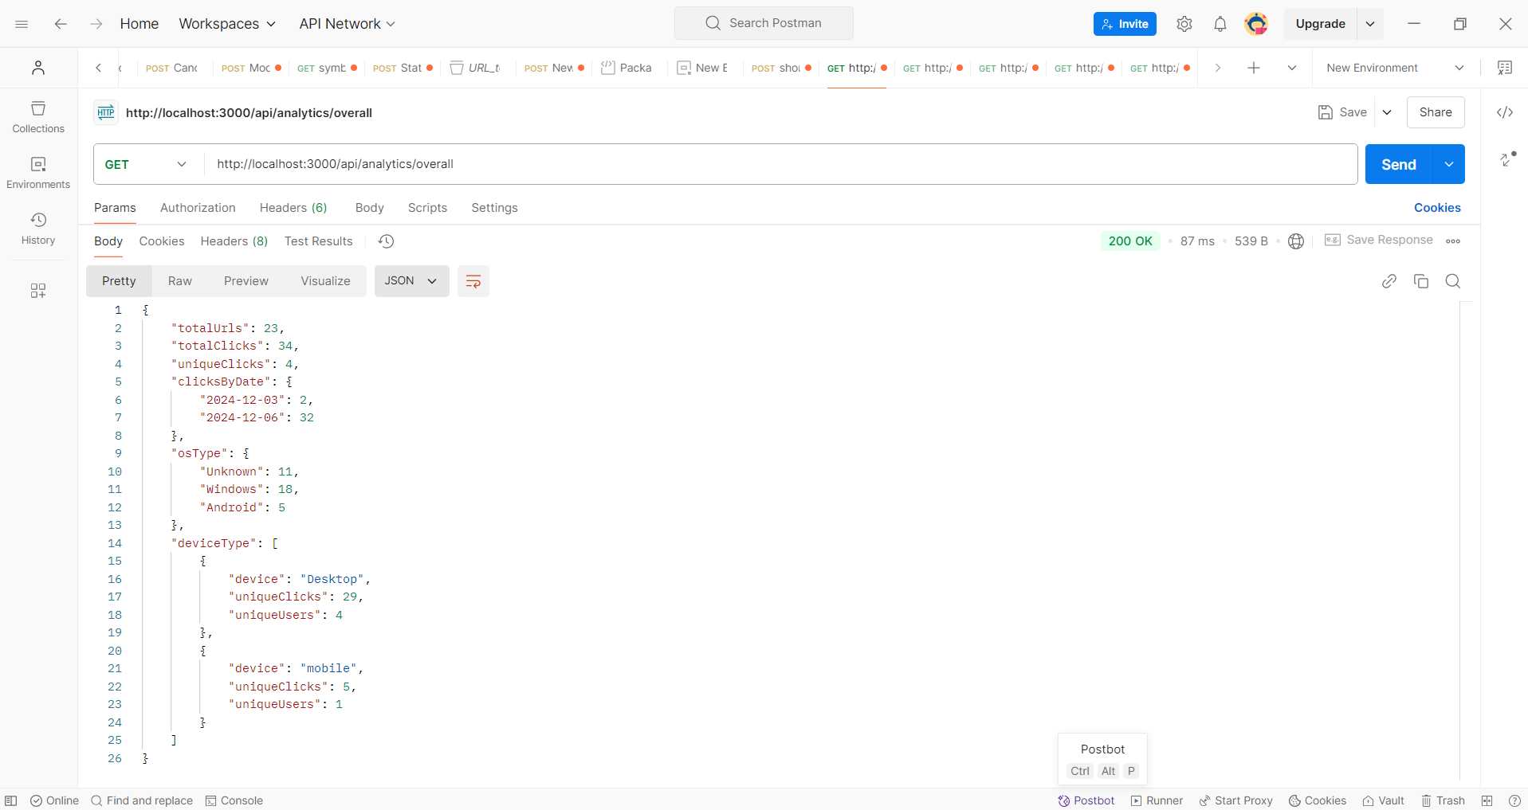

* GET /api/analytics/:alias

Fetch analytics for a specific shortened URL.

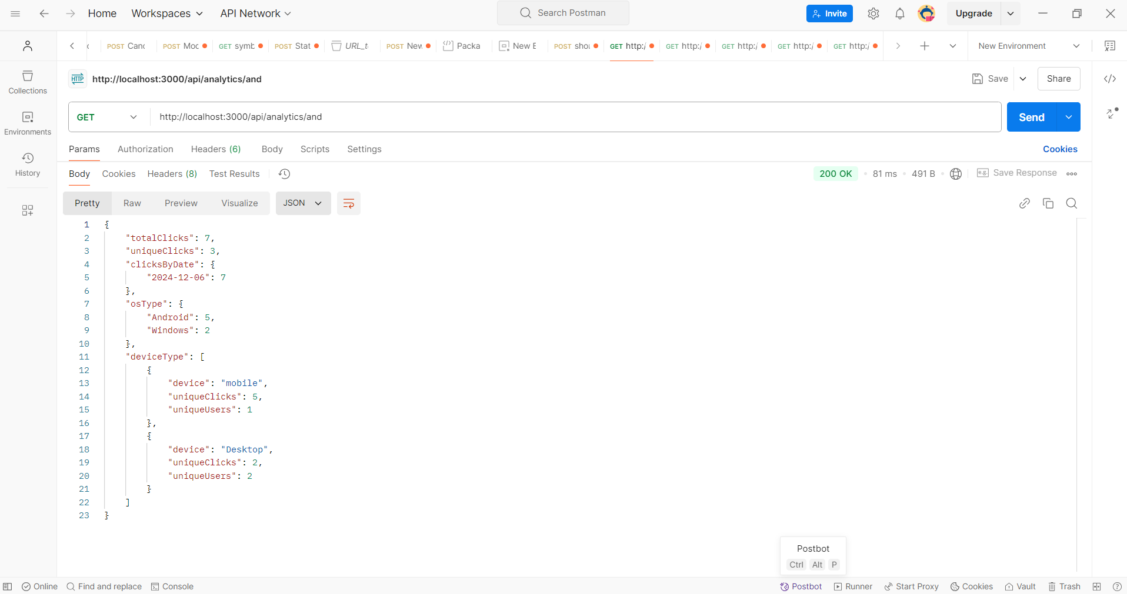

#### 

* GET /api/analytics/topic/:topic

Fetch analytics for a specific shortened URL based on topic

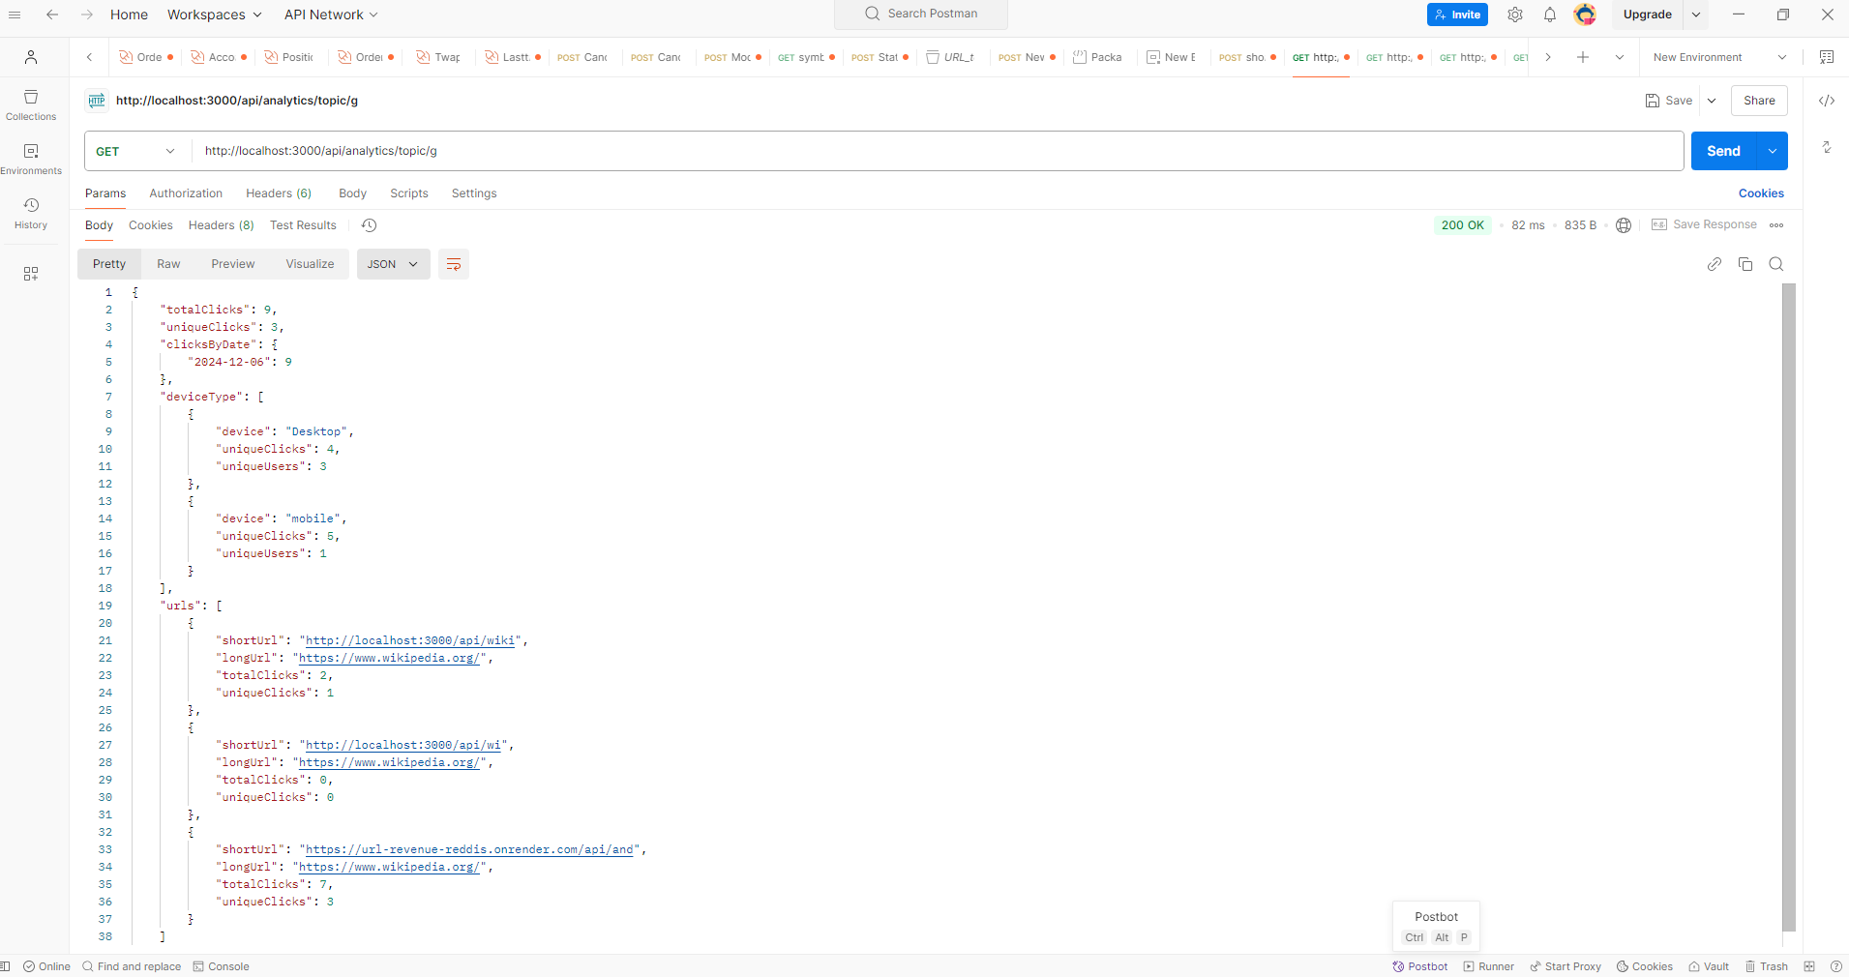

#### **Authentication**

* GET /api/auth/google

Redirects to Google OAuth.

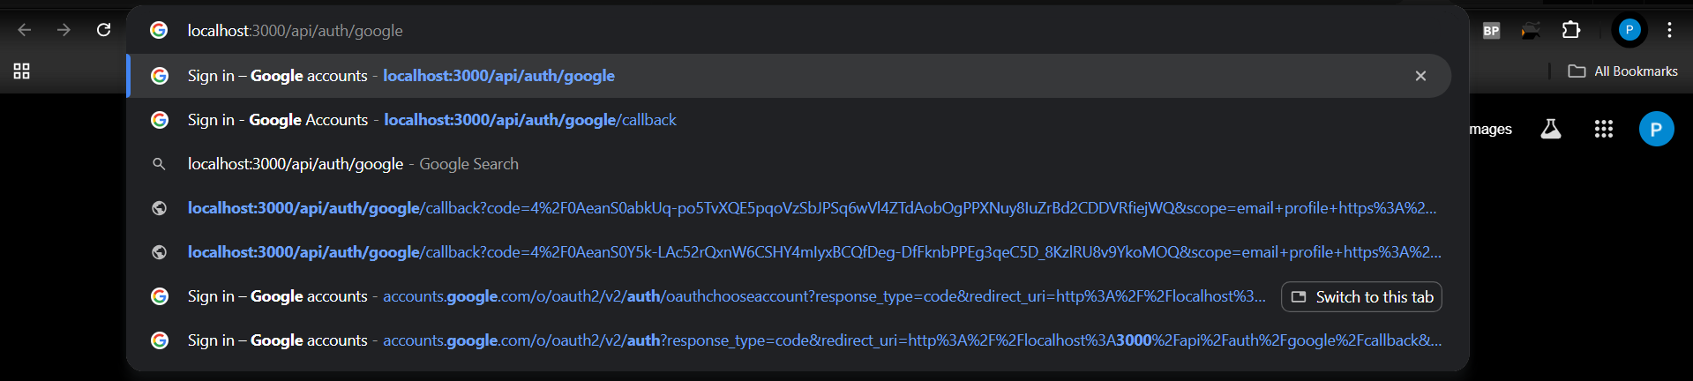

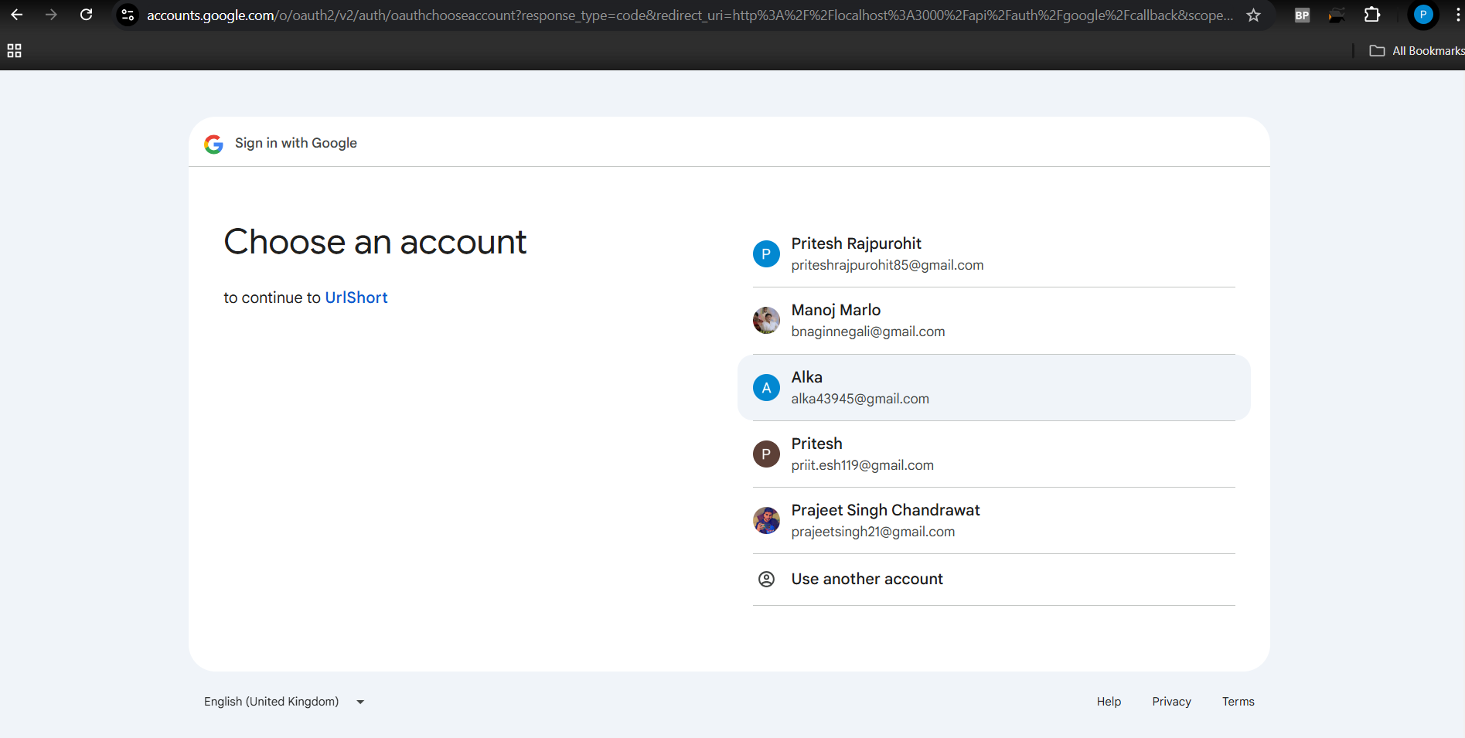

* GET /api/auth/google/callback

Callback for Google OAuth.

